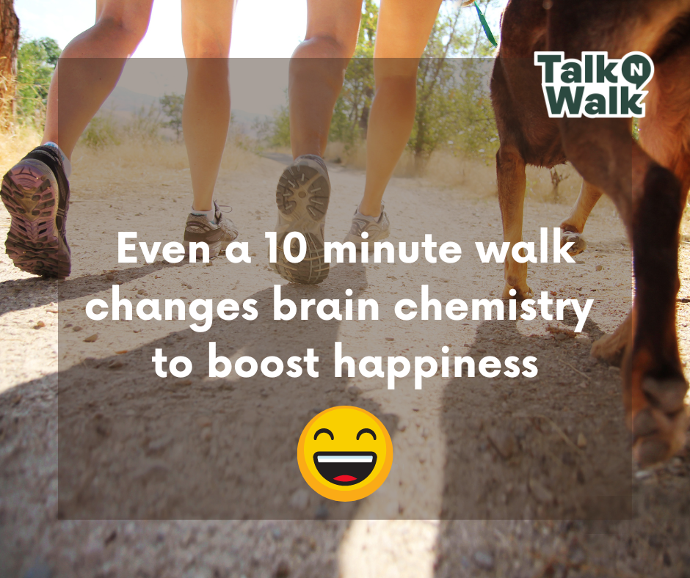Sometimes, some fresh air and simple movement is all it takes to lift your mood!  Walking to school is a great way to set kids up for a positive day, and the Talk N Walk app makes it all the more fun with challenges to conquer, conversation starters and sticker rewards.  In exciting news, we’re hosting a Talk N Walk to School Day on [insert your event date]! Click the link to find out more.  https://www.natureplaywa.org.au/wp-content/uploads/2022/10/2.-Promotional-Flyer-for-Parents-1.pdf | 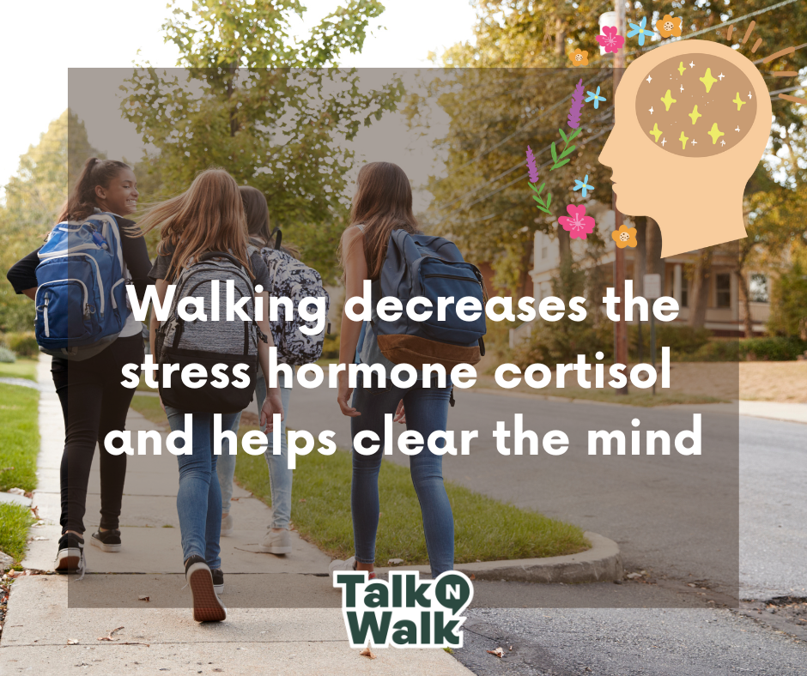Winding down during or after a busy school day is important. A relaxed child is happier, can think more constructively and focus better.  The Talk N Walk app encourages kids to decompress in ways we know work: spending time outdoors, physical movement, and talking with a friend.  We’re celebrating the benefits of walking and talking with a Talk N Walk to School Day on [insert your event date]! Click the link to find out more.  https://www.natureplaywa.org.au/wp-content/uploads/2022/10/2.-Promotional-Flyer-for-Parents-1.pdf
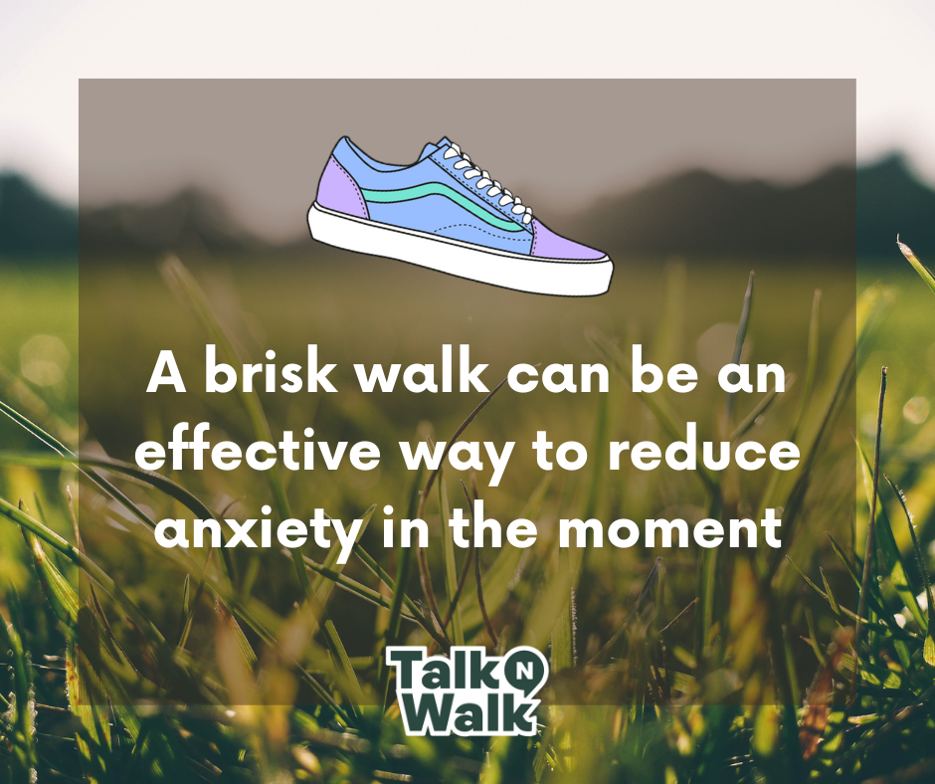School days can pose a number of healthy challenges to our kids – like giving a speech, handling a tricky social interaction, or learning something new – and it’s normal for nerves to creep up.  When they do, a brisk walk can help channel that nervous energy elsewhere. Join us for our Talk N Walk to School Day on [insert your event date] to celebrate the benefits of walking and talking using the Talk N Walk app.  Click the link for details about the event and the Talk N Walk app.  https://www.natureplaywa.org.au/wp-content/uploads/2022/10/2.-Promotional-Flyer-for-Parents-1.pdf | 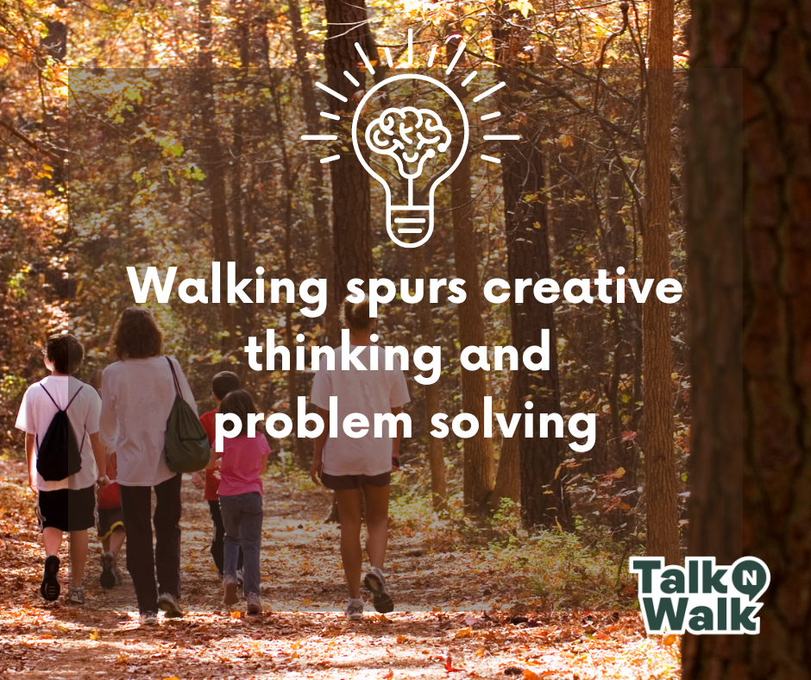Mental blocks happen when the brain is overwhelmed. They can make even the simplest of tasks feel near impossible!  Walking gives your brain a chance to wind down and inspires new ways of thinking as you take in the world around you.  We’re hosting a Talk N Walk to School Day on the [insert your event date], to inspire our students to use walking as a tool to improve their wellbeing.  Find out more about the day by clicking the link:  https://www.natureplaywa.org.au/wp-content/uploads/2022/10/2.-Promotional-Flyer-for-Parents-1.pdf
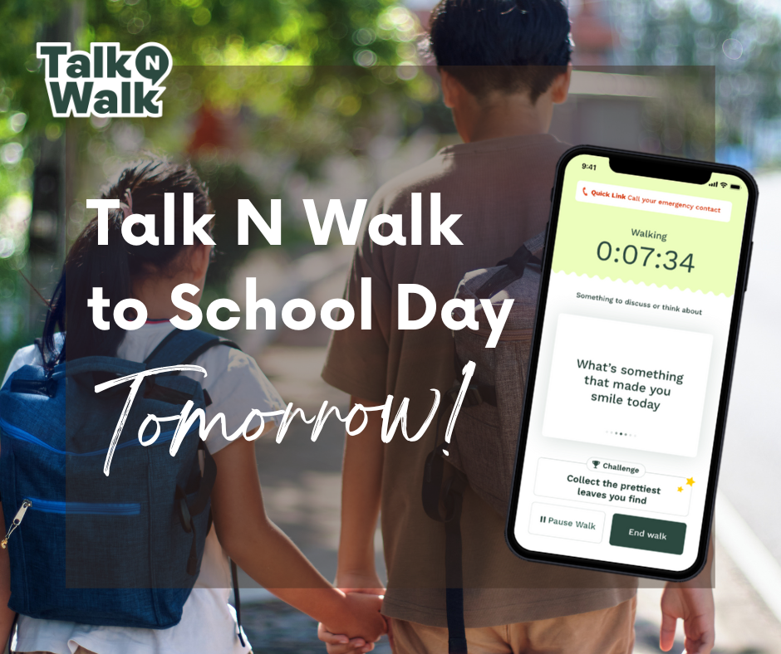Don’t forget to download the Talk N Walk app and change up your family walk to school tomorrow with walking challenges to complete, conversation starters and digital sticker rewards.
Download the app (iOS)
Download the app (Android)

